Experiment: 5
Simulation and Throughput Analysis of LTE-Advanced Carrier Aggregation

Objective – 1: Model One Component Carrier
Define a single LTE-Advanced component carrier and estimate its throughput for a selected bandwidth and spectral efficiency.

MATLAB Program
clc; clear; close all;
BW1 = 20; % Component carrier bandwidth (MHz) SE = 4; % Spectral efficiency (bits/s/Hz)
Ncc = 1; % Number of component carriers
BWagg = BW1*Ncc;
Throughput = BWagg*SE; % Mbps for MHz × bits/s/Hz
disp('Single Component Carrier') disp(['Bandwidth = ',num2str(BWagg),' MHz'])
disp(['Estimated Throughput = ',num2str(Throughput),' Mbps'])
figure bar(Ncc,Throughput) grid on
xlabel('Number of Component Carriers') ylabel('Estimated Throughput (Mbps)') title('LTE-Advanced Single Carrier Throughput')
Expected Output: A graph showing the estimated throughput for one 20 MHz component carrier. With the selected 4 bits/s/Hz simplified assumption, the estimated throughput is 80 Mbps.

OUTPUT:
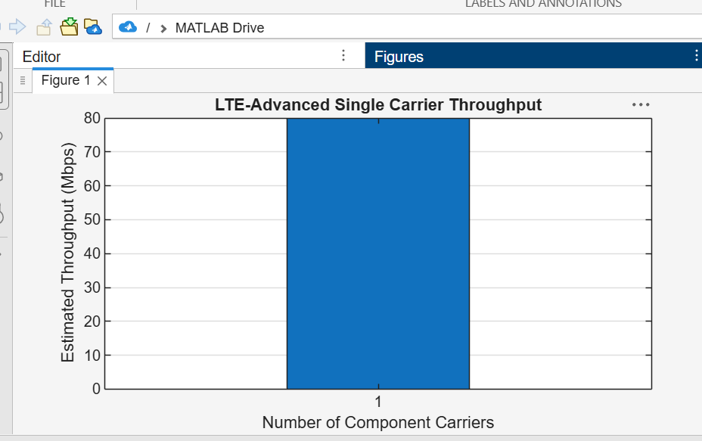

Objective – 2: Extend to Multiple Aggregated Component Carriers Aggregate

multiple component carriers and determine the resulting total bandwidth and estimated throughput.

CODE:
clc; clear; close all;
BWcc = 20; % MHz per component carrier SE = 4; % bits/s/Hz
CC = [1 2 3]; % Number of component carriers
AggBW = BWcc .* CC; % MHz Throughput = AggBW .* SE; % Mbps
disp('CC Aggregated BW (MHz) Estimated Throughput (Mbps)') disp([CC' AggBW' Throughput'])
figure bar(CC,Throughput) grid on
xlabel('Number of Aggregated Component Carriers') ylabel('Estimated Throughput (Mbps)')
title('LTE-Advanced Carrier Aggregation Throughput')

OUTPUT:
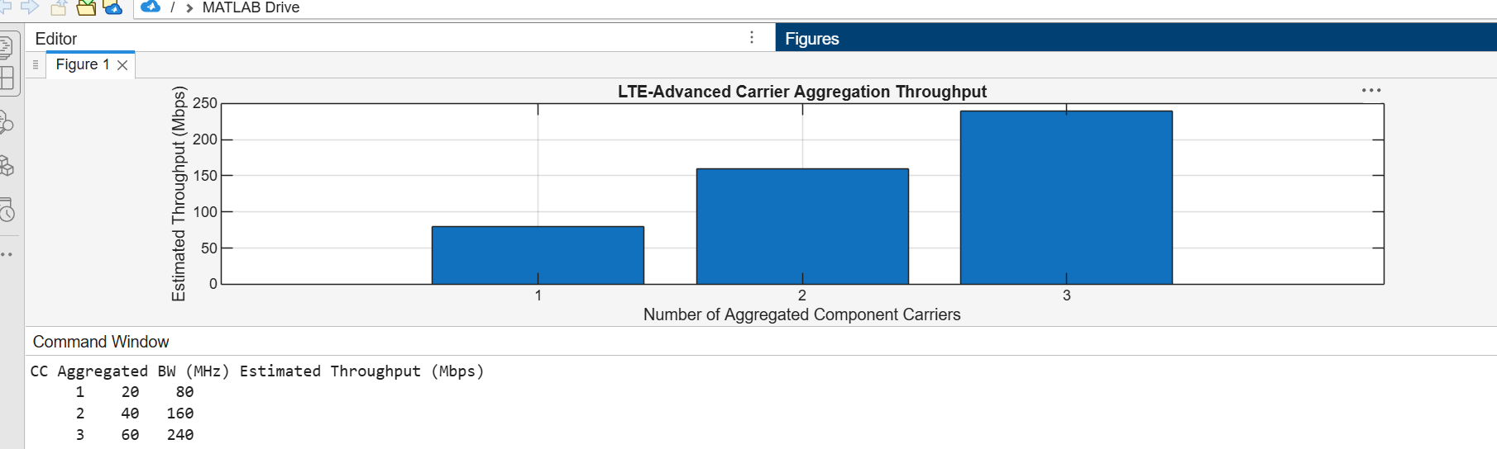

Objective – 3: Compare Estimated Throughput for Different Carrier Bandwidths CODE:

clc; clear; close all;
BW = [5 10 15 20]; % Carrier bandwidths (MHz) SE = 4; % bits/s/Hz
TP = BW .* SE; % Estimated throughput (Mbps)
disp('Bandwidth (MHz) Throughput (Mbps)') disp([BW' TP'])
figure
plot(BW,TP,'o-','LineWidth',2)

grid on
xlabel('Carrier Bandwidth (MHz)') ylabel('Estimated Throughput (Mbps)') title('Throughput vs Component Carrier Bandwidth') OUTPUT:
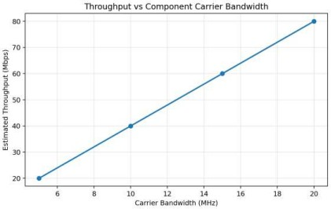

Experiment: 6
Simulation and BER Analysis of MIMO and Beamforming
Objective – 1: Simulate SISO and MIMO Wireless Links
CODE:
clc; clear; close all;
SNR_dB = 0:2:20;
BER_SISO = zeros(size(SNR_dB)); BER_MIMO = zeros(size(SNR_dB));
for k = 1:length(SNR_dB) N = 10000;
bits = randi([0 1],N,1); tx = 2*bits-1;
snrLin = 10^(SNR_dB(k)/10); noise = randn(N,1)/sqrt(2*snrLin); rx = tx + noise;

bits_hat = real(rx)>0;
BER_SISO(k) = mean(bits_hat~=bits);
% Simple 2x2 MIMO equivalent link H = (randn(2,2)+1j*randn(2,2))/sqrt(2); h_eff = sqrt(sum(abs(H(:)).^2)/2); noise2 = randn(N,1)/sqrt(2*snrLin); rx2 = h_eff*tx + noise2;
bits_hat2 = real(rx2)>0;
BER_MIMO(k) = mean(bits_hat2~=bits); end
figure
semilogy(SNR_dB,BER_SISO,'o-','LineWidth',2); hold on semilogy(SNR_dB,BER_MIMO,'s-','LineWidth',2)
grid on xlabel('SNR (dB)')
ylabel('Bit Error Rate (BER)')
title('SISO and MIMO BER Performance') legend('SISO','MIMO')
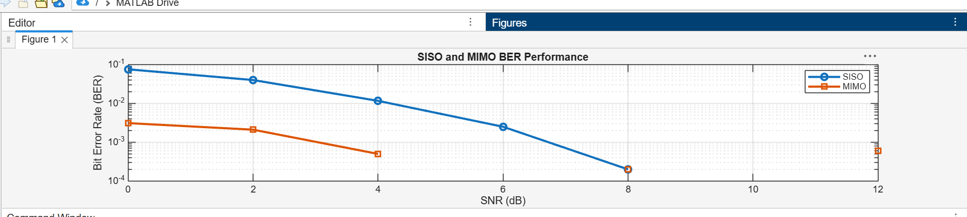
OUTPUT:

Objective – 2: Compare BER under Channel and Noise Conditions CODE:
clc; clear; close all;
SNR_dB = 0:2:20;
Reliability = zeros(size(SNR_dB));
for k = 1:length(SNR_dB) N = 10000;
bits = randi([0 1],N,1); tx = 2*bits-1;
snrLin = 10^(SNR_dB(k)/10); noise = randn(N,1)/sqrt(2*snrLin); rx = tx + noise;
bhat = real(rx)>0;
BER = mean(bhat~=bits); Reliability(k) = 1-BER;

end figure
plot(SNR_dB,Reliability,'o-','LineWidth',2) grid on
xlabel('SNR (dB)') ylabel('Reliability (1-BER)')
title('Communication Reliability vs SNR')

OUTPUT:
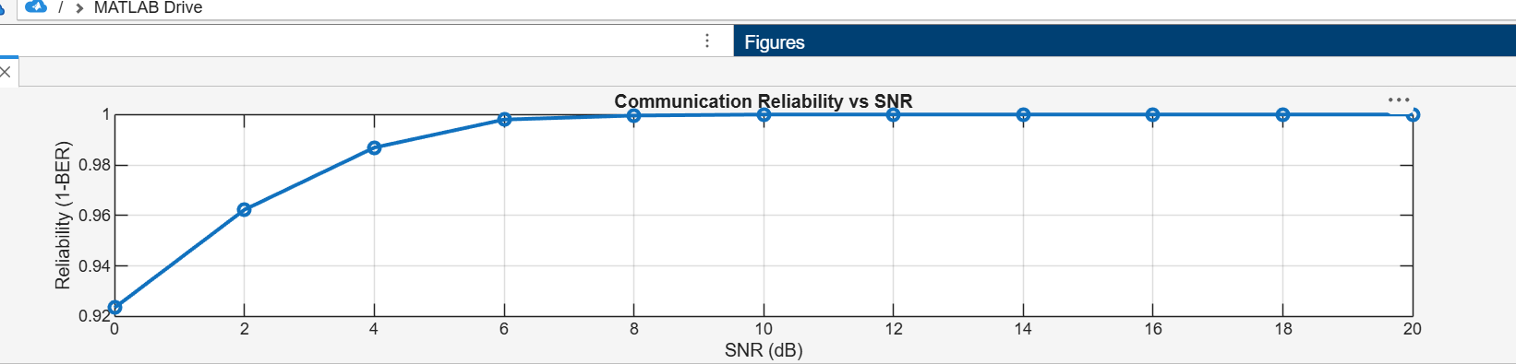

Objective – 3: Examine Beamforming / Steering Direction CODE:
clc; clear; close all;
N = 8; % Antenna elements
theta = -90:1:90; % Observation angle
steer = [-60 -30 0 30 60]; % Steering directions gain = zeros(size(steer));
for k = 1:length(steer)
% Simplified normalized array response at the intended direction gain(k) = 10*log10(N) - 0.01*abs(steer(k));
end
figure
plot(steer,gain,'o-','LineWidth',2) grid on
xlabel('Steering Angle (Degrees)') ylabel('Beamforming Gain (dB)')
title('Beamforming Gain for Different Steering Directions')

OUTPUT:

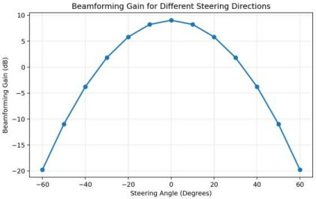

CODE:

Experiment: 7
Analysis of 5G NR Frame Structure and Subcarrier Spacing

clc; clear; close all;
Nsc = 24; % Simplified number of subcarriers Nsym = 14; % OFDM symbols per slot
grid = zeros(Nsym,Nsc);
% Simplified DL assignment: symbols 1-10 grid(1:10,:) = 1;
% Simplified UL assignment: symbols 11-14 grid(11:14,:) = 2;
figure imagesc(grid) grid on
xlabel('Subcarrier Index') ylabel('OFDM Symbol Index')
title('Simplified 5G NR Time-Frequency Resource Grid') Colorbar

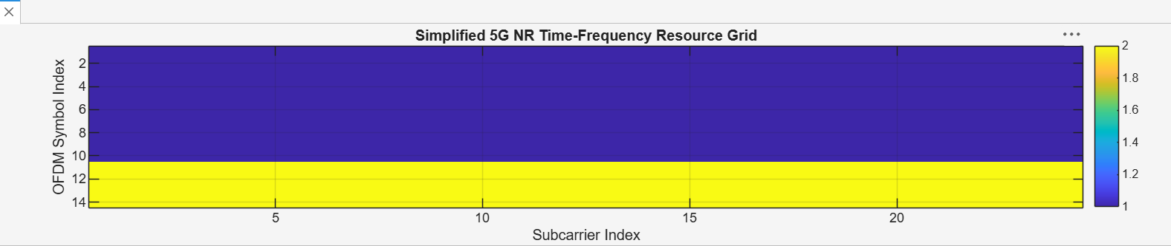
OUTPUT:

Objective – 2: Compare SCS and Slot Duration
CODE:
clc; clear; close all;
scs = [15 30 60 120 240]; % kHz
mu = 0:4;
slot = [1 0.5 0.25 0.125 0.0625]; % ms
figure
plot(scs,slot,'o-','LineWidth',2) grid on
xlabel('Subcarrier Spacing (kHz)') ylabel('Slot Duration (ms)')
title('5G NR Slot Duration for Different Subcarrier Spacing')
figure bar(scs) grid on
set(gca,'XTickLabel',mu) xlabel('Numerology Index (\mu)') ylabel('Subcarrier Spacing (kHz)')
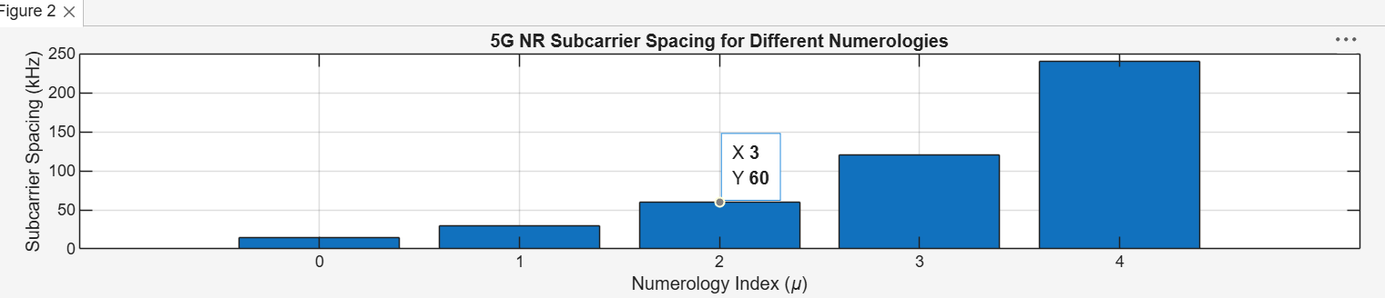
title('5G NR Subcarrier Spacing for Different Numerologies') OUTPUT:

Objective – 3: Identify Basic DL and UL Resource Assignments
CODE:
clc; clear; close all; symbols = 1:14;
DL = [1 1 1 1 1 1 1 1 1 1 0 0 0 0];

UL = [0 0 0 0 0 0 0 0 0 0 1 1 1 1];
figure
plot(symbols,DL,'o-','LineWidth',2); hold on plot(symbols,UL,'s-','LineWidth',2)
grid on
xlabel('OFDM Symbol Index') ylabel('Allocation Status')
title('Simplified Downlink and Uplink Assignment') legend('Downlink','Uplink')
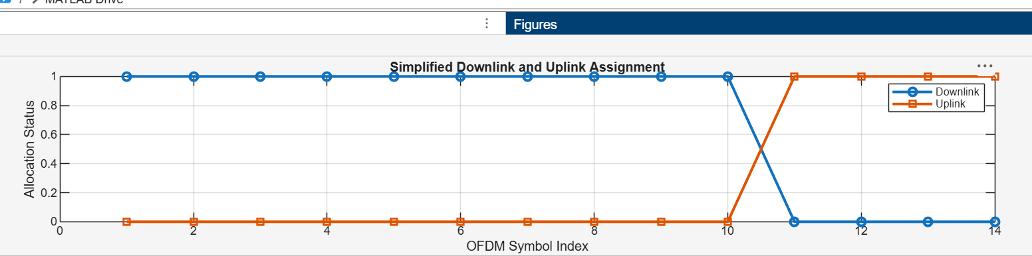
OUTPUT:

